Please read the following instructions and notes carefully before submitting the Withdrawal & Refund Request form:
- Please submit the completed form with the supporting documents to the School at 100 Orchard Road #04-100 Concorde Hotel Singapore 238840 or via email at feedback@aventisglobal.edu.sg.
- The School will process the Student’s request by the next working day and process the refund to the Student within 7 working days (if any).
- The review process will not take more than four (4) weeks from the receipt of the duly completed Withdrawal & Refund Request Form, and the Student will be notified in writing on the outcome via Notification of Course Withdrawal.

SECTION A (FOR STUDENT)
Name of Student |  | NRIC/FIN/Passport No.
Email |  | Mobile Phone
Course Title |  | Commencement Date (DD/MM/YYYY)
Reason(s) for Withdrawal (Please tick accordingly)
☐ Health (Attach Medical Certificate)
☐ Official Overseas Posting ((Attach Company Letter)
☐ Others (Attach Written Letter of Explanation/Supporting Documents)
☐ Please specify:

I hereby submit my withdrawal request and understand the following:
(a) that the paid course fee is refundable on following conditions:

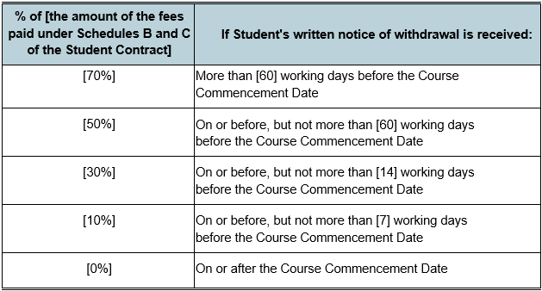

- In the event that a company-sponsored student withdraws, the company is liable to pay any outstanding fees. Student who wishes to pursue the course after withdrawal shall be considered as a new applicant for the course
- Student shall be informed of the outcome of the withdrawal application in writing. Approval of withdrawal is at the sole discretion of the School
- International students are required to cancel their student’s passes as required by the Immigration and Checkpoints Authority upon approval of the withdrawal

I agree to bear all consequences resulting from this withdrawal.
_____________________________  Student’s Signature | _____________________________  Date

SECTION B: STUDENT SERVICE DEPARTMENT (OFFICIAL USE ONLY)
Interview Remarks:
Student still wish to withdraw: ☐ Yes ☐ No |  |  | Eligible for Refund: ☐ Yes ☐ No
If eligible for refund, please indicate the payment date, amount paid, receipt/invoice number and the refund amount (with the calculation):
 | Signature
Student Service Executive's Name |  |  |  | Date
SECTION C: FINANCE DEPARTMENT (OFFICIAL USE ONLY)
Amount of Refund: S$

Remarks:
 |  | Date
Processed by

